Force-o-rama

The Challenge

Can you create a three (or more!) step machine to help you complete an everyday task in isolation by only touching the contraption once yourself.

Make a Force-o-rama demonstrating at least three
forces in action.

Forces you could show:
Gravity / Magnetism / Contact / Applied
Friction / Spring / Non-Contact

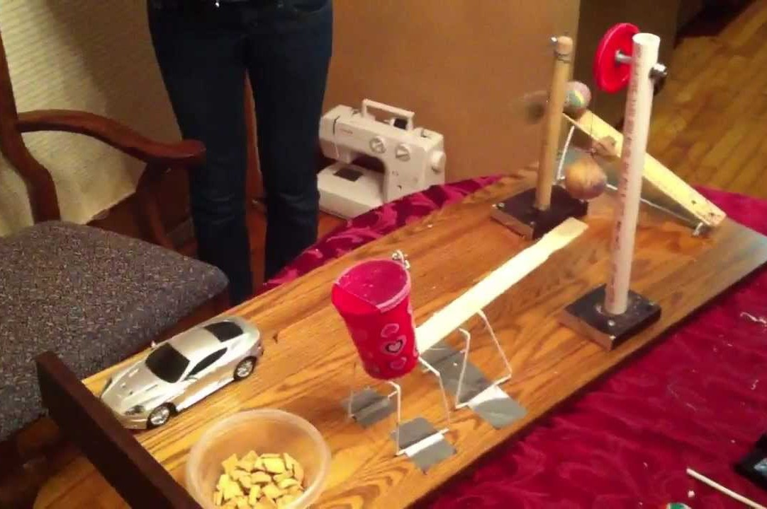
The Process

Follow the Engineering Design Process to help you complete this task:

1. Ask questions: What is the problem? Are there any challenges?

2. Imagine it: Look for some inspiration and brainstorm your ideas. Pick the best one!

3. Plan it: Make a list of materials you will use. Draw a diagram with labels.

4. Create it: Follow your plan. Create a model.

5. Improve it: Did it work? Can you make it better? What could ne done differently?

6. Share it: What changes need to be made? What do others think?

Materials

The materials you could use are endless, but here are some ideas:

paper plates, straws, paper, glue, cardboard, masking tape, cups, cardboard tubes, marbles, weights, magnets, toy cars, ramps, string, blocks, balloons, empty can, icy pole sticks, water, sand dominoes, a fan or anything else you can safely use from home.

Stages 1 and 2

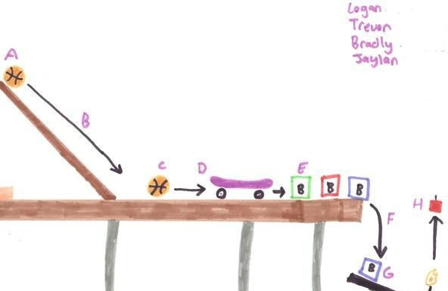What is the problem that your contraption will solve?

Names of family members involved:

Gathering inspiration - record some ideas that you want to try here.
List, draw or paste photos.

The goal of our contraption:

Stage 3

We will use the following materials:

Diagram of our contraption
- Include labels of the materials, simple machines and forces you want to include.

Our contraption is called
results & reflection
Stage 5

Draw a picture showing what happened when your contraption was tested.

How could you make your contraption better? Draw a diagram of your improved contraption, and label any changes, e.g. shorter ramp, heavier weight, use of different materials, etc.

